**Some observations:**

~~Section 1:~~ **~~Word Peace Pagoda in Lumbini~~**~~– to be corrected as World~~

~~Section2: There are two sets of Pictures of Princess Nanda~~

Section 3: The picture : **Ascetic Siddhartha reflecting on his new freedom beside the river Anoma.** Underneath” Image: Specially created by Chat: GPT” to be deleted and insert as an End Note.

~~Section 7 : The Image: The Buddha the Supreme Teacher- Can the figure be little large?~~

Section 8: Can these damages be bit large? 1) **The Buddha and his Bhikkhu and Bhikkhuni disciples**

**2) Devas paying homage to the Blessed One 3) King Pasenadi paying homage to the Buddha**

Section 9: The image : After countless eons wandering through the vast cycle of saṃsāra, … I have cut the Yakka figure but it has appeared in the webpage . This is the right one:

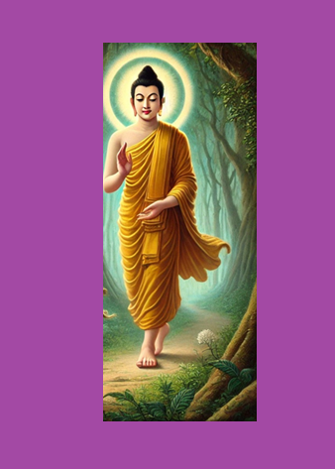

**~~After countless eons wandering through the vast cycle of saṃsāra, the Bodhisatta at last fulfilled his supreme aspiration—bringing an end to all rebirths. In this final existence, he descended into the world one last time, not for himself, but to illuminate the path of liberation for the welfare and happiness of all beings.[1]~~**

~~Section 10: the image- can this be large? :~~ **~~The Samma Sambuddha~~****~~The Dhamma is the profound teaching~~**

Section 12: Can the image be large? **The compassionate Buddha**

1. AI generated image.